Civil war in Somalia

UNSC Resolution: | 885
Date of adoption: | 16-Nov-1993
Operative paragraph: | 6
Demand number: | 885,0611

Sarah-Myriam Martin-Brûlé

Wording of demand
- fully cooperate with the Commission

List of addressees of the demand
- Government of Somalia, United Somali Congress Faction

Short-term compliance

Description of the addressee(s)’ conduct

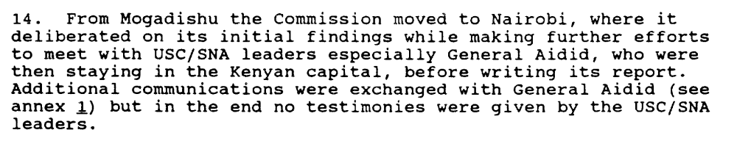

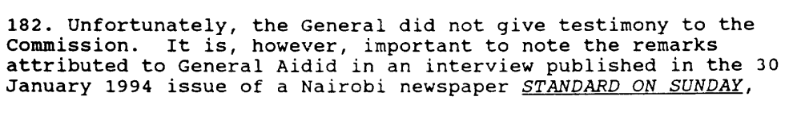

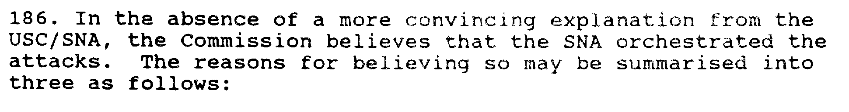

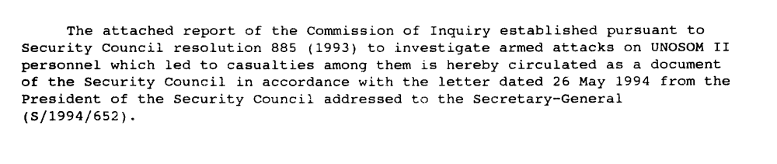

S/1994/653

Assessment

Short-term compliance
X No or marginal compliance (1) | Medium low compliance (2) | Medium high compliance (3) | Full or almost full compliance (4)

Considerations underlying the assessment

The parties did not consent to give their testimonies to the commission.

Medium-term compliance

Description of the addressee(s)’ conduct

S/1994/653

Assessment

Medium-term compliance
X No or marginal compliance (1) | Medium low compliance (2) | Medium high compliance (3) | Full or almost full compliance (4)

Considerations underlying the assessment

The parties did not consent to give their testimonies to the commission.

Depth of demand

Assessment

Level of depth of demand
X Low depth of demand (1) | Medium depth of demand (2) | High depth of demand (3)

Considerations underlying the assessment
Compliance with this demand did not put the survival of the demand addressees at risk nor did it have a significant impact on their chances to attain victory.

Level of confidence about coding decisions

Level of confidence about coding decision
Extremely high | X High | Moderate

Comments to IPI (if any)

